READNOW: Newtons First Law Date:05/12/2025
Newton’s First Law tells us how objects move.
It says: “Objects keep doing what they are already doing unless a force changes it.”
This means:
- If an object is not moving, it will stay still unless a force acts on it.
- If an object is moving, it will keep moving at the same speed and direction unless a force acts on it.
- When no forces change the motion, we say the forces are balanced.
- When a force does change the motion, we say the forces are unbalanced.
This idea is linked to inertia.
Inertia means objects do not like changes to their motion.
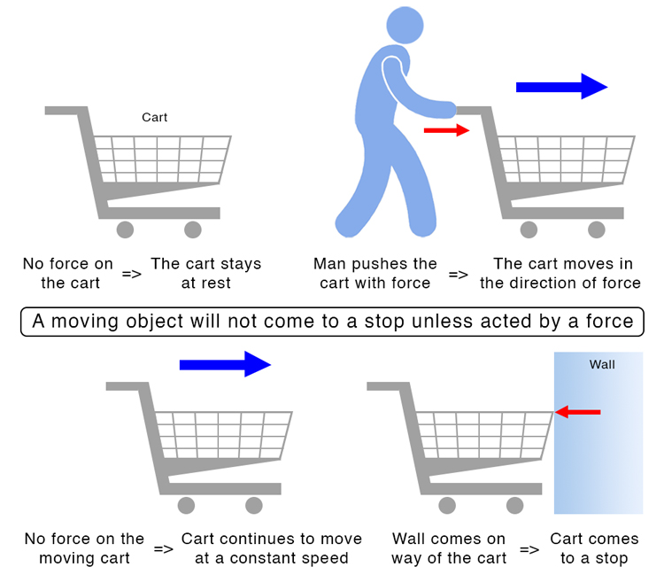

QUESTIONS
- What does Newton’s First Law tell us about objects?
- What happens to an object that is not moving if no force acts on it?
- What happens to a moving object if the forces are balanced?
- What word do we use when a force changes the motion?
- What is inertia?

